Conduct penetration test:
DEMO:
Hydra -l root -P /usr/share/seclists/passwords/10-milliom-pass.txt ssh://ip_address -t 2 -v
Either we are doing before remediation then we have to get risk ratio to it.
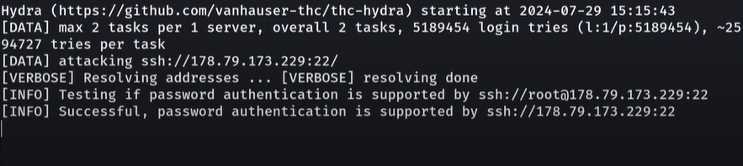

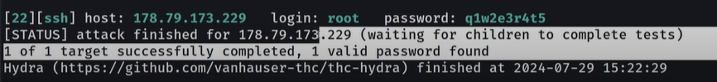

Edit the config file to not llow for the password:
Cd /etc/ssh/
Sudo sshd_config

Note:
Change the thing according to policy as mentioned in the remediation. Such as change the port in the config file.
✅ Fail2ban = A Linux security tool that protects servers from brute-force attacks.

🔹 What it does:
- Monitors log files (e.g., SSH, Apache, FTP).
- Detects repeated failed login attempts.
- Automatically bans the attacker’s IP using firewall rules (like iptables or firewalld).
- Ban can be temporary (e.g., 10 minutes) or permanent.

